### A Report on

### Online Appointment System Website

### (June - 2019)

**Submitted for Bachelors of Technology in Computer Science Engineering**

By

**­­Aayush Mehta**

**Department Of CSE, SRM Institute of Science and Technology, Chennai**

**B.Tech**

**Registration no.-RA1811003010343**

**Under the guidance of**

. . . . . . . . . . .

**J.L. Bind**

**Scientist ‘E’**

Head, Neuro Computing and Simulation Department

**INSTITUTE OF NUCLEAR MEDICINE AND ALLIED SCIENCES (INMAS) DEFENCE RESEARCH AND DEVELOPMENT ORGANINZATION (DRDO)**

**(**Ministry of Defence, Govt. of India)

**CERTIFICATE**

This is to certify that a Mr Aayush Mehta s/o Brig Ramit Mehta, a student of B.Tech. 3rd Semester at SRM Institute Of Science and Technology, Chennai has carried out his project work titled “Online Appointment System Website” under my supervision 3rd June, 2019 to 1st July, 2018 as part of the training his 3rd Semester B.Tech Computer Science Engineering.

Date :

. . . . . . . . . . .

Sh. J. L. Bind,

Scientist ‘E’,

Institute of Nuclear Medicine and Allied Sciences,

DRDO, Delhi

**ACKNOWLEDGEMENTS**

I would like to express my sincere gratitude to Shree J. L. Bind for the continuous support to my research project, with his patience, motivation, enthusiasm, and immense knowledge. I am extremely thankful for his sincere and diligent effort as a mentor; he inspired me during all times, good or challenging. His expertise has been influential on the research as well as on my career.

Special thanks to my family. Words cannot express how grateful I am to my mother, father, and brother for all the sacrifices. Your prayers and blessings took me thus far.

I would also like to thank all my friends (Shubham Yadava, Kalyani Kashyap) who supported and encouraged me to strive hard for my goal.

**ABSTRACT**

Whenever we cross a clinic or a hospital, one thing which we always see is the line of patient’s waiting to get an appointment of the doctor. This is a result of on the spot or physical appointment system booking. The patient has to physically come to the clinic to get an appointment of the doctor even for their 2nd or 3rd appointment. This leads to chaos and waste of manpower as well, leaving both the doctors and the patients unsatisfied. This system was long due to be changed.

To provide a solution to this, we proposed an Online Appointment System Website. Our proposed system can make an appointment for a patient to the clinic depending on the doctor’s availability and upon the schedule of the clinic. All that needs to be done is that the patient has to register on the website of the system and then login. After that the patient needs to select the department and the doctor, then the patient has to go and select an appropriate date and depending on the schedule the appointment will be made. In the portal, the patient can also see his/her upcoming and already expired appointments as well. The portal also caters for a doctor’s aspect too. The doctor may login to the portal and update or see his monthly schedule, set his daily appointment limit and also see the patient history as well. This system provides an easy and convenient for both the doctor and the patient and for the clinic as well.

**CONTENTS**

Certificate………….……………………………………………... 2

Acknowledgement...……………………………………………... 3

Abstract………………. …………………………………………….. 4

**Organisation Profile**

Defence Research and Development Organization (DRDO) … 6

Institute of Nuclear Medicine and Allied Sciences (INMAS) … 6

**Introduction**

1.1 Problem statement ……………………………………………... 8

1.2 Objective………………………………………………………… 8

1.3 Advantage and Disadvantage of Offline Appt.………………. 9

1.4 Proposed work………………………………………………...... 8

**Methodology**

2.1 Patients Registration………………………………………………. 09

2.2 Patients Appointment ………………………………………... 11

2.3 Doctor’s Side………………….…………………………… 13

2.4 Edit Profile and Reset Password ……………………………… 14

**Result and discussion**

**Conclusion**

**References**

**List of figures**

**ABOUT THE ORGANISATION**

**Defence Research and Development Organization (DRDO)**

DRDO was formed in 1958 from the amalgamation of the then already functioning Technical Development Establishment (TDEs) of the Indian Army and the Directorate of Technical Development & Production (DTDP) with the Defence Science Organization (DSO). DRDO was then a small organization with 10 establishments or laboratories. Over the years, it has grown multi-directionally in terms of the variety of subject disciplines, number of laboratories, achievements. DRDO is a network of more than 50 laboratories which are deeply engaged in developing defence technologies covering various disciplines, like aeronautics, armaments, electronics, combat vehicles, engineering systems, instrumentation, missiles, advanced computing and simulation, special materials, naval systems, life sciences, training, information systems and agriculture.

**Institute of Nuclear Medicine and Allied Sciences (INMAS)**

At the instance of Pandit Jawaharlal Nehru, the first Prime Minister of India, a Radiation Cell was established in 1956 at Defence Science Laboratory, Delhi. The initial assignment was to undertake a study on the consequences of the use of nuclear and other weapons of mass destruction. But it was soon realized that nuclear energy can also be harnessed for the good of the mankind. Radioisotopes could find peaceful medical applications. The scope of work was, therefore, enlarged and the cell upgraded to Radiation Medicine Division in 1959.

Institute of Nuclear Medicine & Allied Sciences (INMAS) is a laboratory of the Defence Research and Development Organization (DRDO). Located in New Delhi, it is involved in Nuclear medicine research and responding to nuclear accidents and explosions. The department of nuclear medicine under the institute offers a two year diploma in radiation medicine since 1968, making it the first formal training program in nuclear medicine in the world. The origin of the institute can be traced back to the establishment of a Radiation Cell in 1956 at Defence Science Laboratory, Delhi. The cell was later upgraded to Radiation Medicine Division in 1959 and to the Institute of Nuclear Medicine and Allied Sciences in 1961.

**INTRODUCTION**

Appointment Booking has always been the more convenient and wiser method of visiting a doctor, since it books a slot and forms a procedural method of how the doctor-patient interaction works. There are a few methods of how and appointment may be made, the two most prominent and famous ones are: Offline method and the Online method. The offline method had been prevalent for quite some time but turned out to be less efficient and very time consuming , with the advent of technology it was seen that the online system would be better and much more efficient as well. Every online appointment system consists of a patient and doctor side, along with the feature to book and monitor appointments as well.

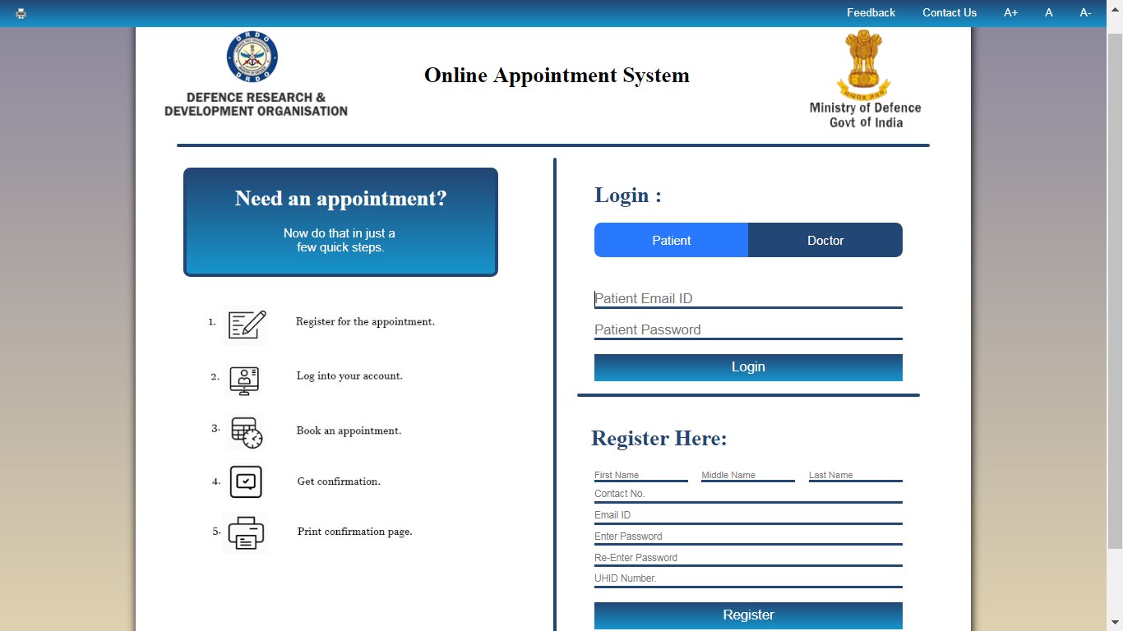

Figure 1. Basic Homepage of the Website

With the advent of Web development, we decided that this project would be better of as a website. The languages which were used primarily are HTML5, CSS, JavaScript, MySQL and PHP as well for both the front end and server side programming. The base idea was to create an interface for both the patient and doctor to track appointments and schedule their tasks accordingly.

**1.1 Problem Statement**: In the beginning, booking an appointment was quite an easy task, but with the population increasing every day it has become a tedious task. With patients crowding clinics and forming never ending lines, it makes it very uncomfortable for all the patients and for the doctors too, as they have to see more amount of patients in a limited time and hence they can dedicate lesser time to each patient which creates a source of error and in the field of medicine they should be absolutely no scope of making a mistake.

**1.2 Objective**: This project mainly aims to come up with a solution to tackle the raising demand of appointments to be made. For which we have devised an online appointment system, which registers a patient on the portal website, subsequently the patient can login to the portal and can book an appointment from the comfort of their home and avoid the chaos of making an on spot booking. It is also intended that an application with same purpose may be created which would assist all users who do not have a computer. This simplifies the long and tedious tasks of making an appointment and digitalizes the entire process.

**1.3 Advantages and drawbacks of Offline Appointment Booking**

Advantage of Offline Appointment booking

1. It ensures that the appointment in made right in front of the patients eyes and also gives the patient an extra visit to acquaint themselves with the clinic.

Drawback of Offline Appointment booking

1. Very long lines of patients, causing discomfort to the elderly and severely ill patients and to the hospital’s management as well.
2. A doctor who has to see the patients in a limited amount of time has to see a lot of patients but time is very less, hence he gets less time with every patient.
   1. **Proposed Work:** The Internet has emerged to be the centre of the new and modern world. Our base thought was to utilise this power and use it to our favour. Hence the idea of a website emerged. The website is to create a portal for the Patients and for the doctors to maintain their schedule and foresee any appointments and to create their schedule accordingly. The website is created using front end languages like HTML5, CSS and uses JavaScript as well. For the purpose of the database, we used MySQL and PHP was used for the purpose of server side programming. The website has been tested on the local server and works without any problem and is ready to be hosted on a proper server.

**METHODOLOGY**

The online appointment booking website creates two sides: one for the patient and the other for the doctor. The basic process which is to be followed is that the patient first registers on the website. Upon registration, the patient is now eligible to login to the portal, followed by this the patient selects the department and the doctor and then books an appointment for a particular date. The doctor can also login to his own profile and view his appointments for the day and the entire month.

**2.1 Patient’s Registration and Login:**

Upon reaching the homepage of the website the patient is first supposed to register with the website by giving his details like Name, Contact No, Email address and UHID as well. The patient is required to carefully fill the given form as any minor error, like a field left blank would result in an error from the webpage and registration would be unsuccessful.

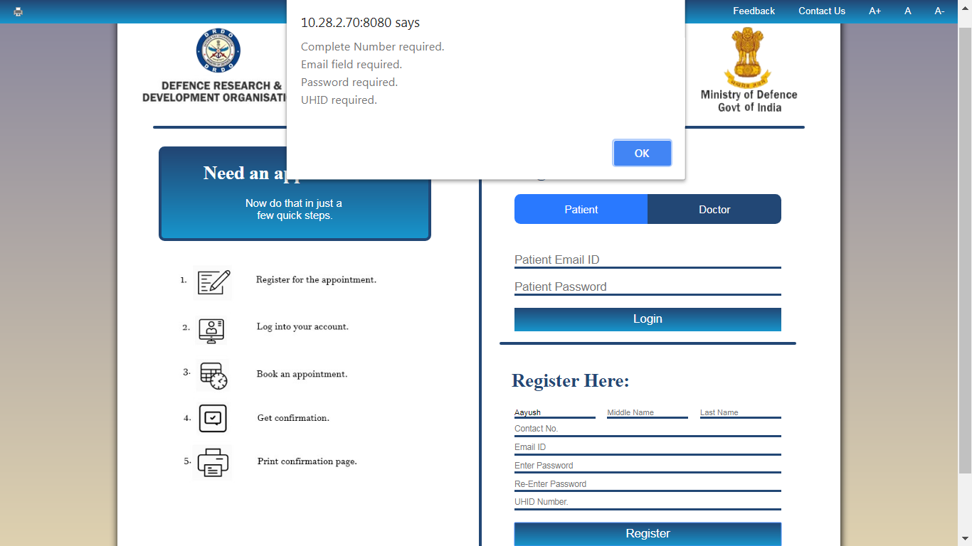

Figure 2. Registration Errors

Figure 3. Successful Registration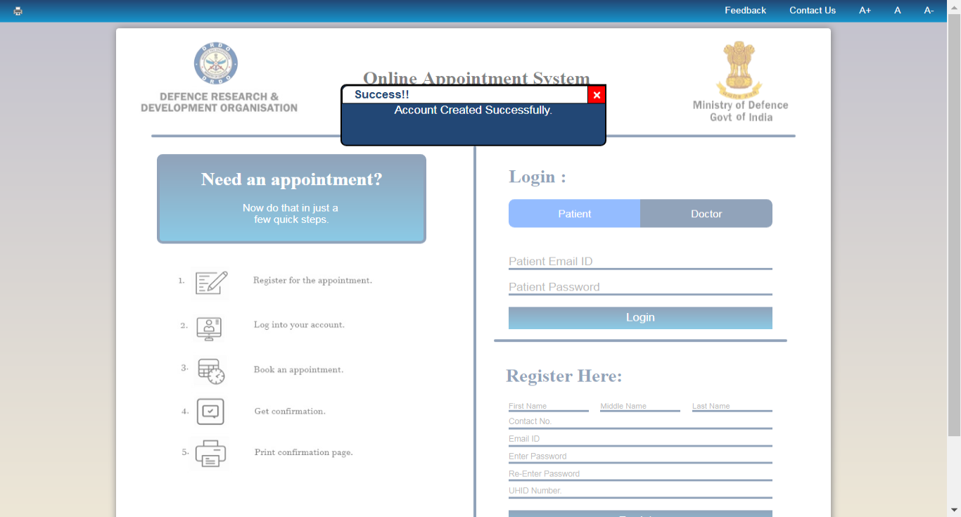

Now after this step, the patient is required to enter their credentials into the login column of the webpage subsequent to which they will be logged in to the page.

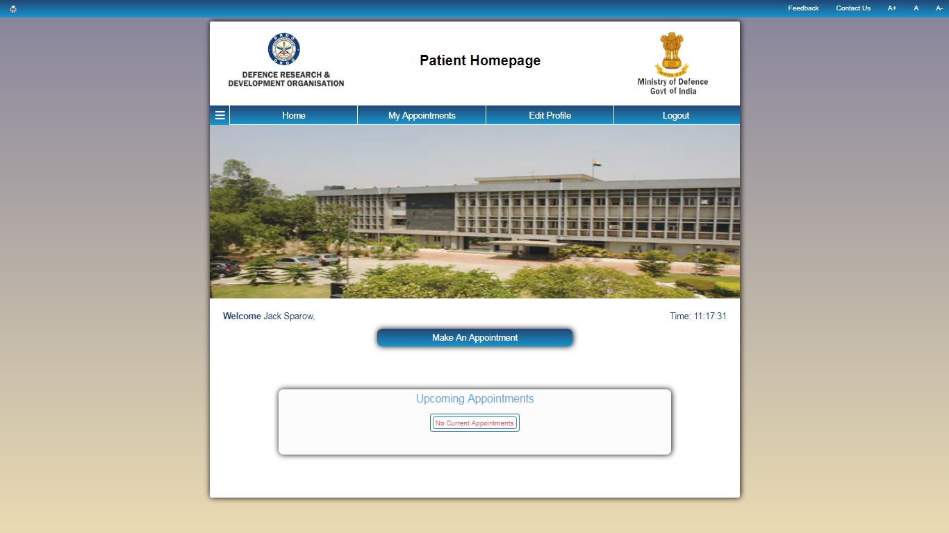

Figure 4. Patient Home

**2.2 Patient’s booking an Appointment:**

The patient upon entering the homepage is required to go and select their department and doctor. After this the patient clicks on the make an appointment button and is taken to the date selection page where the set date is checked and if available the date is booked for an appointment.

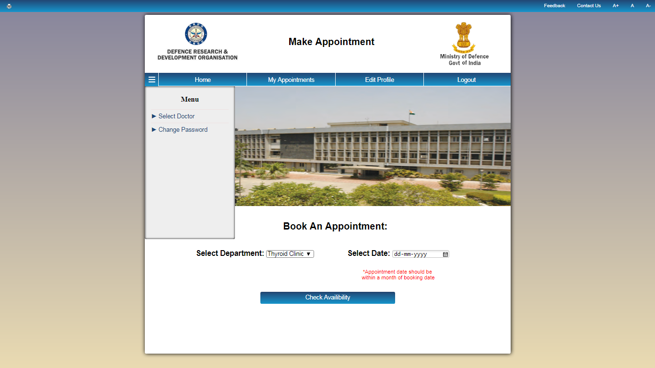

Figure 4. Select Doctor Menu and Book an Appointment Page.

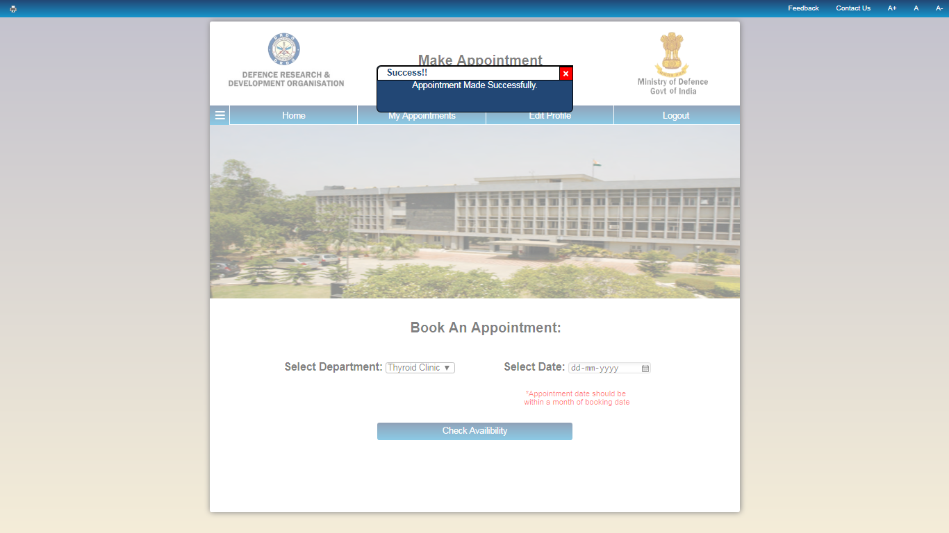

Figure 5. Appointment Successful.

Upon having booked an Appointment, the patient can go the my appointments tab and review their scheduled appointments and can print their information as well.

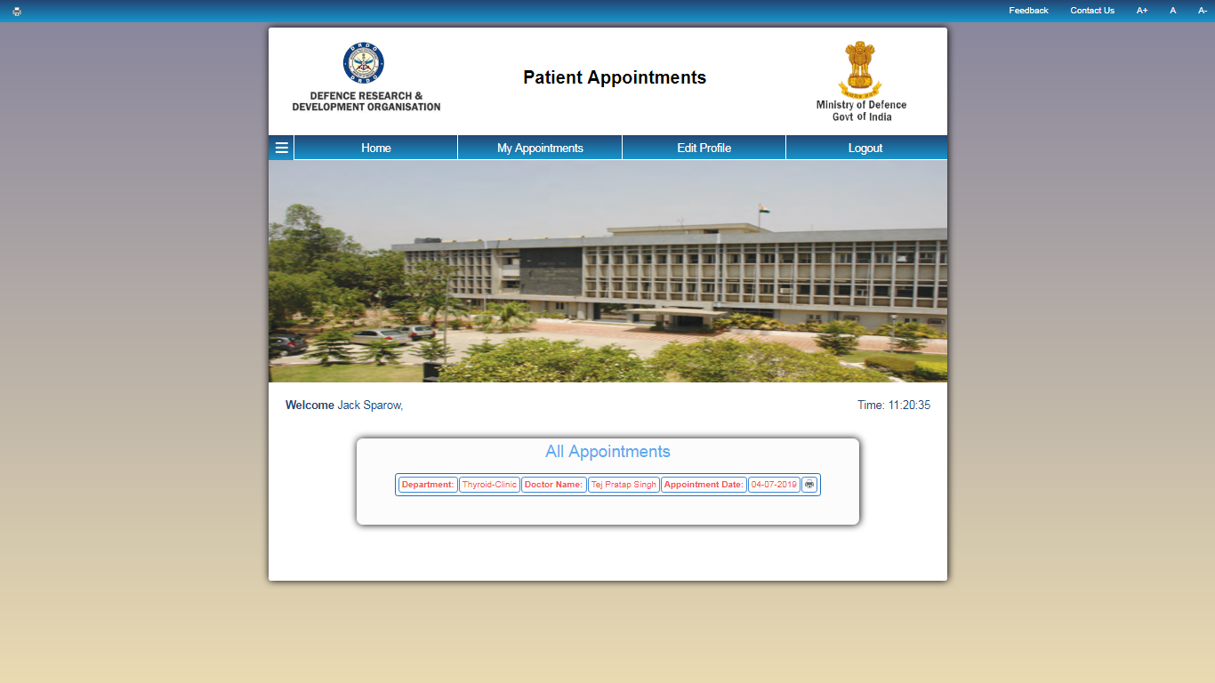

Figure 6. All Appointments

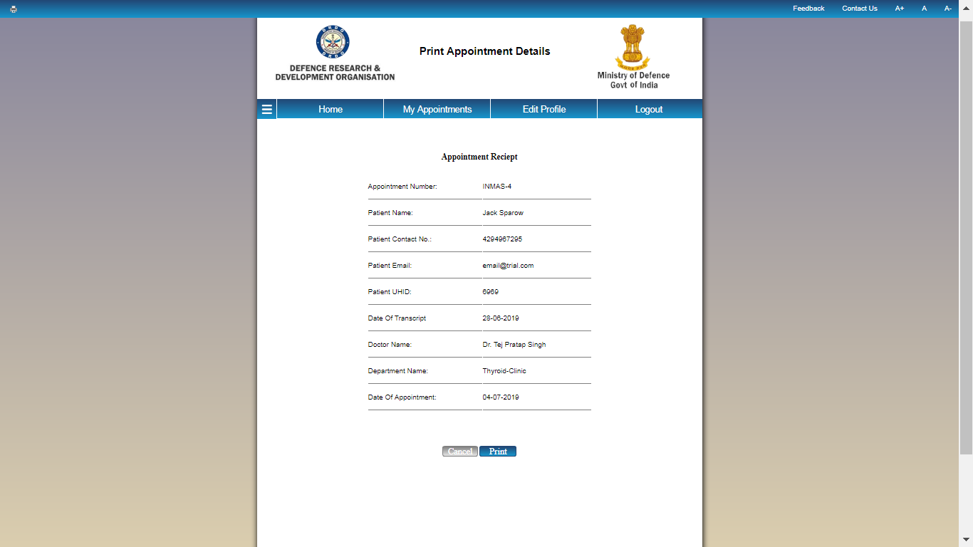

Figure 6. Appointment Receipt

**2.3 Doctor’s Side:**

The doctor also has an option of logging into his account and viewing the appointments scheduled for the day and also change the limit of appointments per day and also view his calendar for the entire month. The doctor and patient both have the option to reset their password and edit their profile as well.

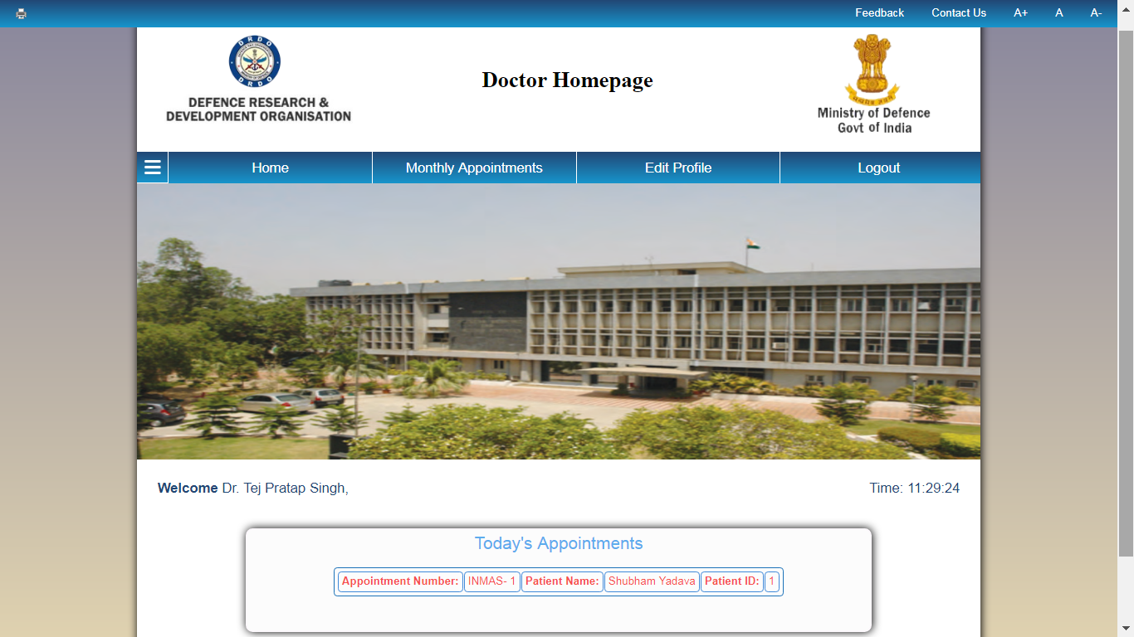

Figure 7. Doctor’s Homepage.

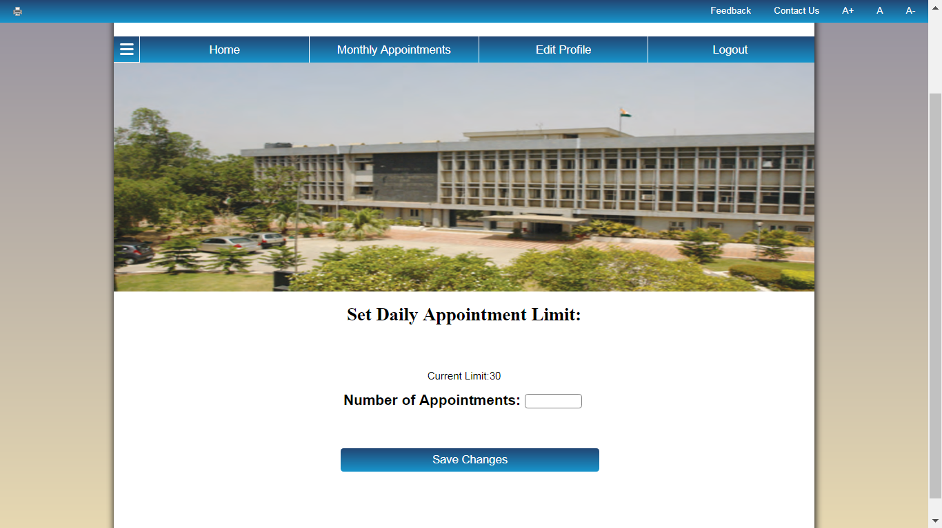The doctor first sets the limit of patients he can see that day, and then can see his monthly schedule as well

The doctor can also see his entire month’s calendar by clicking on the Monthly Appointments button and click on any specific day to see that day’s appointments. The calendar is colour coded to show the availability of the doctor that day depending upon the number of appointments.

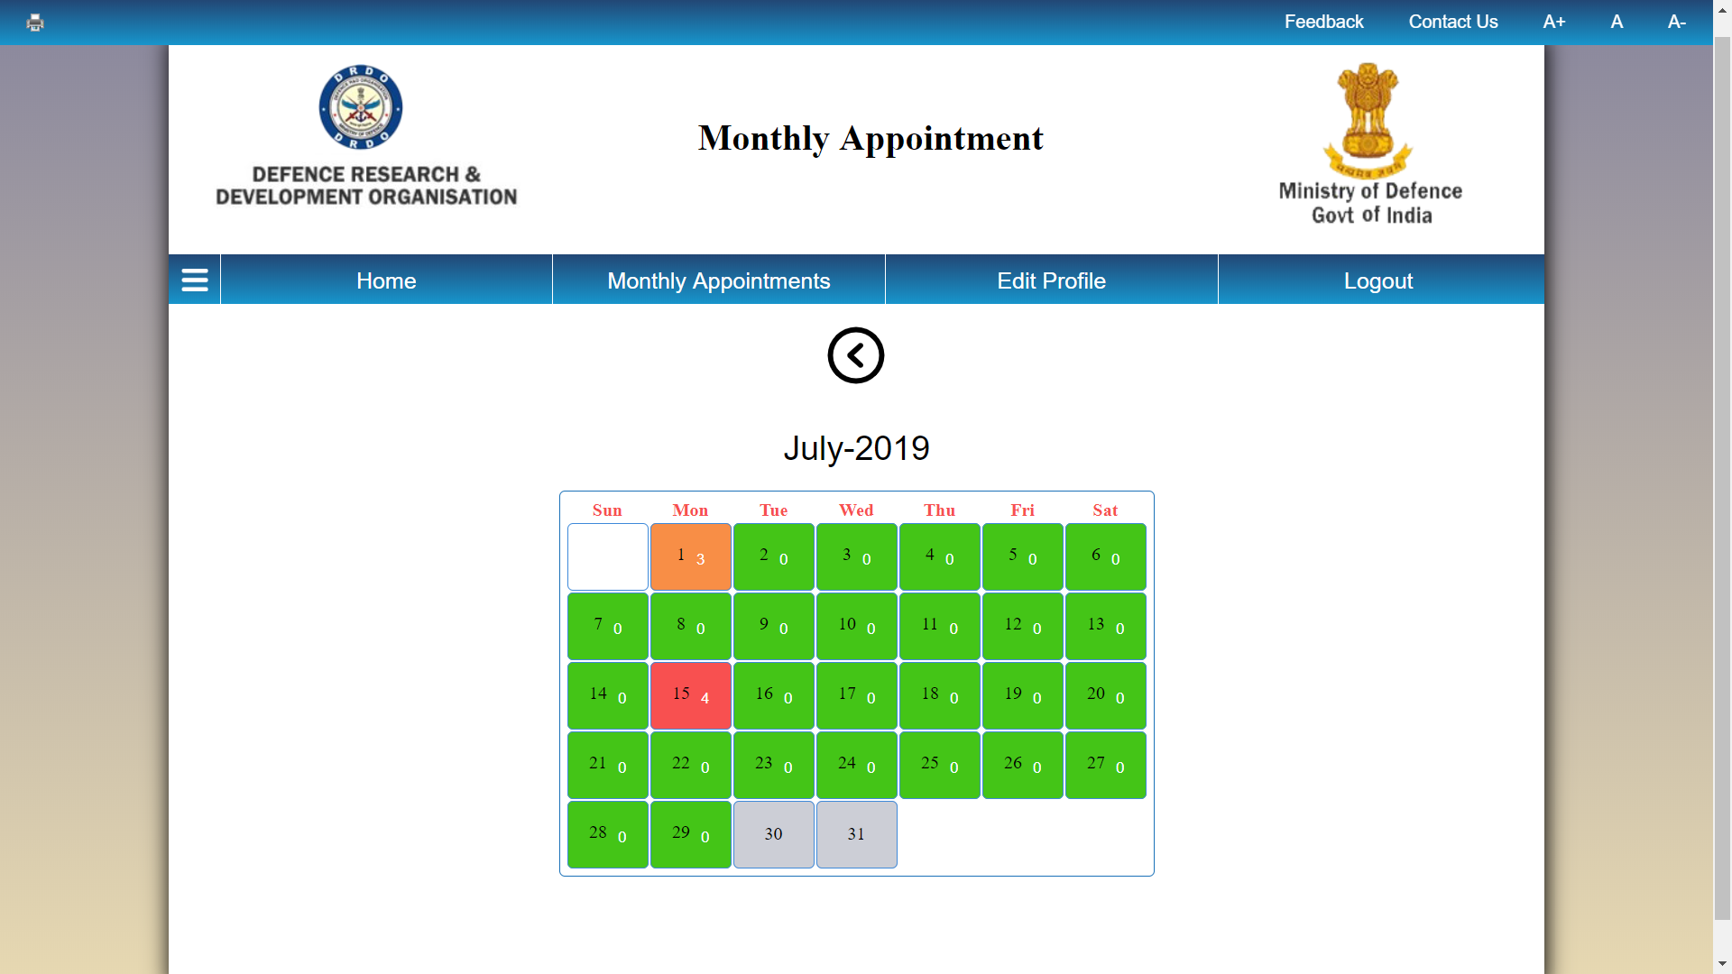

Figure 8. Monthly Calendar

**2.4 Edit Profile and Reset Password:**

There are two attributes which are common to both the doctors and the patients site and those are: The Edit Profile button and the Reset Password button. The edit profile tab enables them to change any errors which may be present in their profile and to add additional details too. The Reset Password enables them both to change the password of their account.

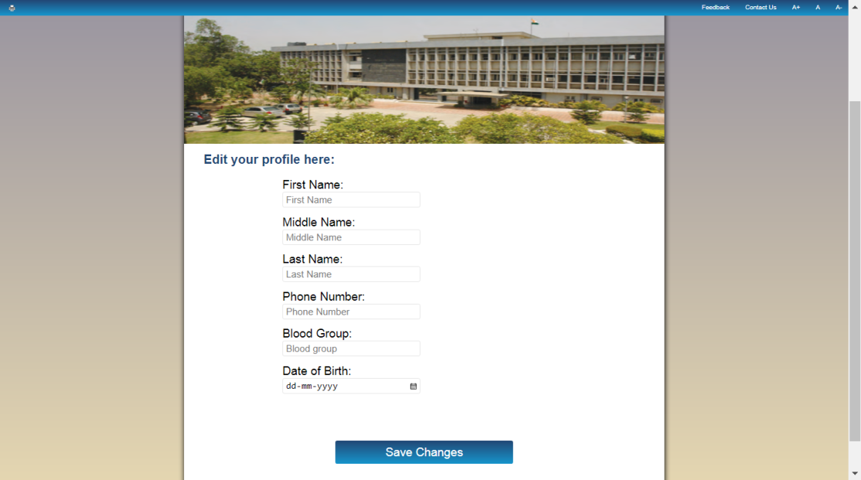

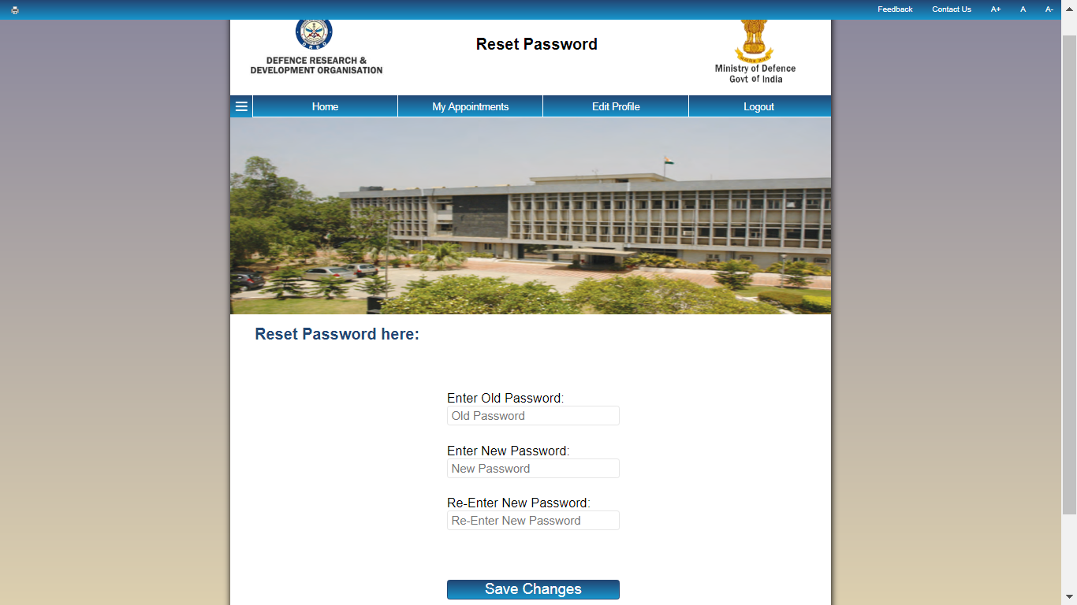

Figure 9. Reset Password and Edit Profile.

**2.4 Doctor Administrator**

An Administrator is also created in the doctor’s side which has the access to create and delete doctor’s profile and add other administrator’s too. The administrator gets the id and timestamp of every other administrator which has signed into the Portal.

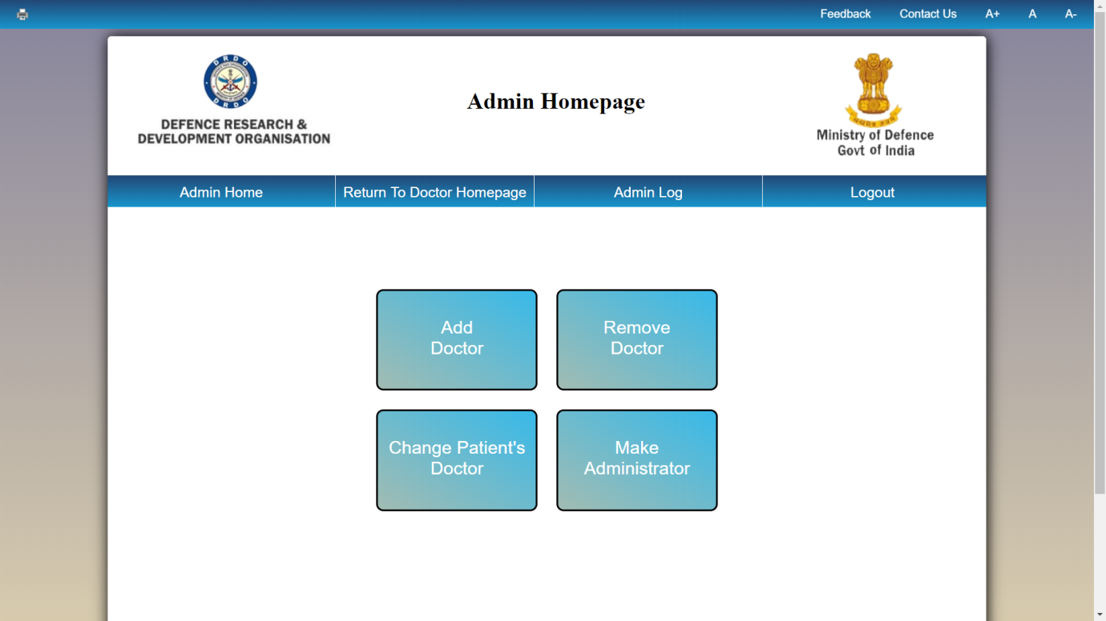

Figure 10. Doctor Administrator

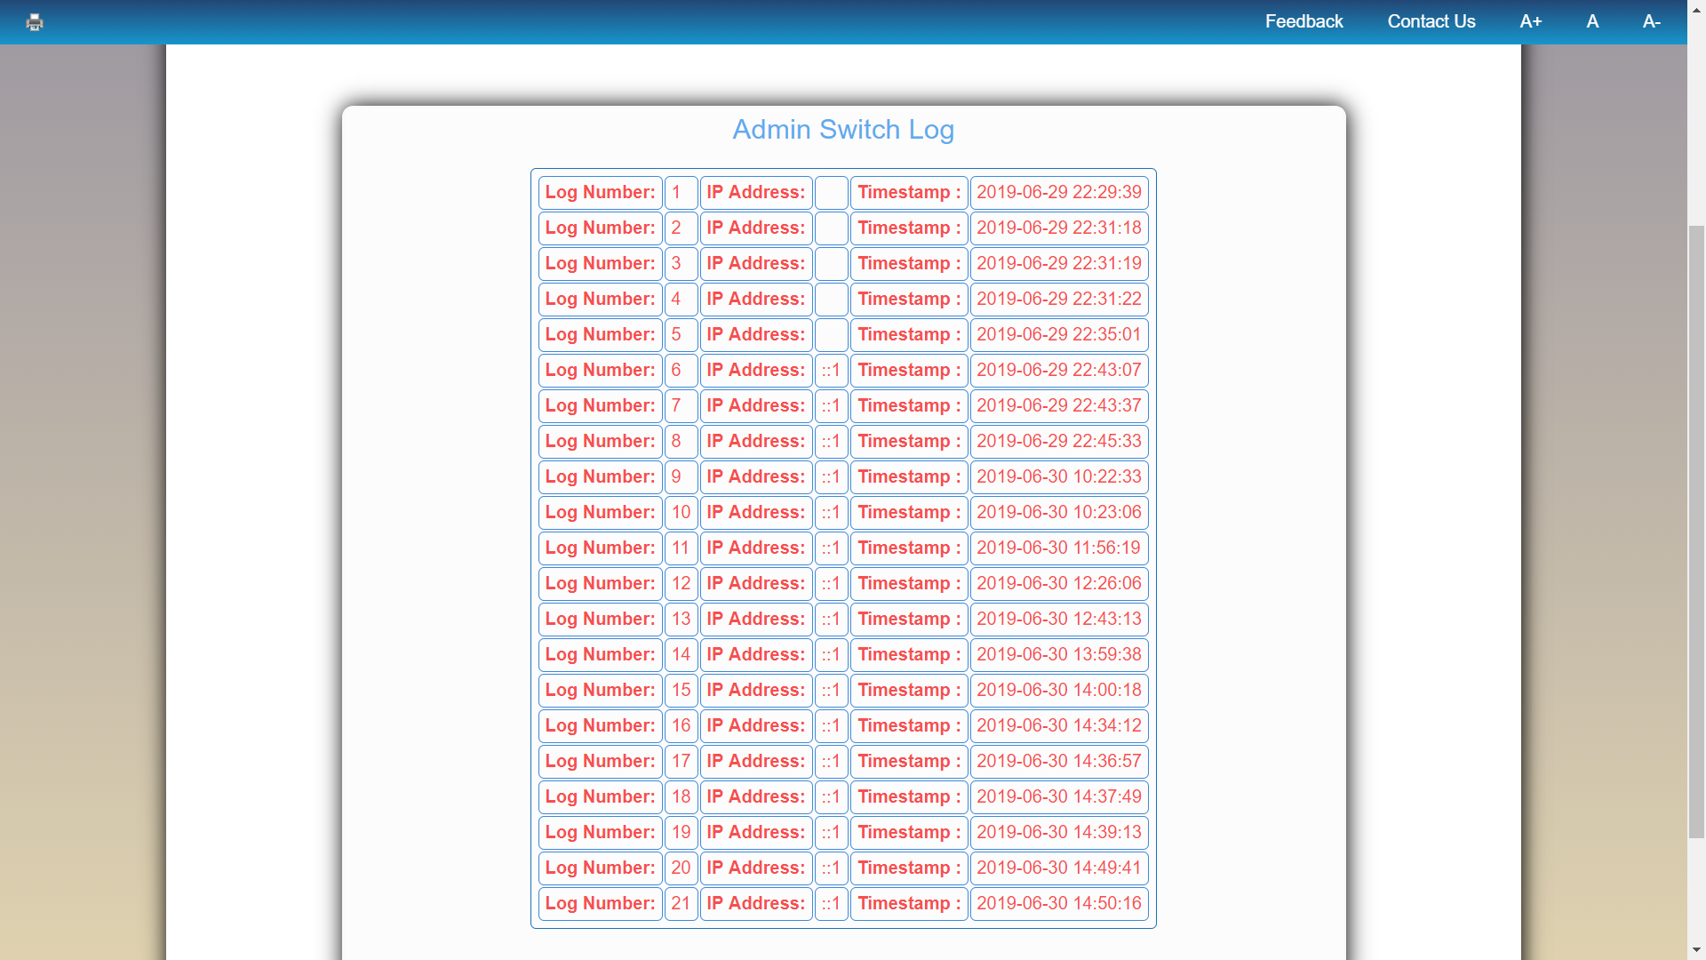

Figure 11. Doctor Administrator Log

**Result and Discussion:**

As seen earlier in the report the Appointment is made on the Patient Side and can be seen in the doctor’s schedule as well. The patient is able to make an appointment based on the availability of his doctor and the doctor to whom the appointment has been made can also see it as well.





Figure 12. Appointment Confirmation.

**Conclusion**

In this project the webpage was created using languages like HTML5, CSS, JavaScript, MySQL and PHP. The webpage was created and hosted on the local server too. Various test cases were made to check the functionality of the website and each and every error was tested, rectified and documented for further reference. The Webpage now stands completed.

**References**

1. <http://www.w3schools.com>
2. <http://Stackoverflow.com>
3. <http://Github.com>

**List of Figures**

1. Basic Homepage Of Website .………………… ……... 7
2. Registration Errors ………..........…...…………………... 09
3. Successful Registration…………...………………………... 10
4. Patient Home…………………………………………… …. 10
5. Appointment Successful……………………..................... ... 11
6. All Appointments …………………………………………. ..12
7. Doctor’s Homepage ………………………………………… 13
8. Monthly Calendar …………………………………………. 14
9. Edit Profile and Reset Password ……………………………..15
10. Doctor Administrator…………………………………………15
11. Doctor Administrator Log…………………………………….16
12. Appointment Confirmation…………………………………...17